**Dockers :**

• Docker is**an open source containerization platform.** It enables developers to package applications into containers—standardized executable components combining application source code with the operating system (OS) libraries and dependencies required to run that code in any environment.

Docker is an open platform for developing, shipping, and running applications. Docker enables you to separate your applications from your infrastructure so you can deliver software quickly. With Docker, you can manage your infrastructure in the same ways you manage your applications.

By taking advantage of Docker’s methodologies for shipping, testing, and deploying code quickly, you can significantly reduce the delay between writing code and running it in production.

 Docker has the ability to reduce the size of development by providing a smaller footprint of the operating system via containers. With containers, it becomes easier for teams across different units, such as development, QA and Operations to work seamlessly across applications

Docker file It is a file, comprised of multiple layers, used to execute code in a Docker container. They are a set of instructions used to create docker containers. 2. Docker Container It is a runtime instance of an image. Allows developers to package applications with all parts needed such as libraries and other dependencies

## Container Management CLIs

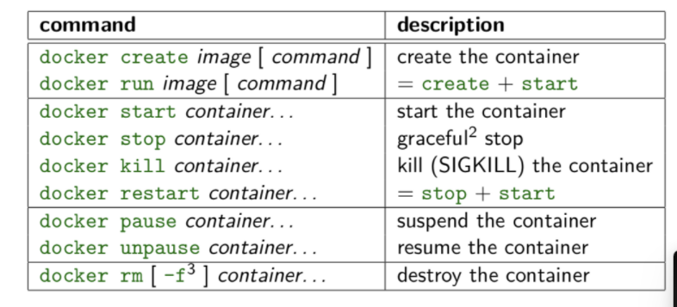

## Inspecting The Container

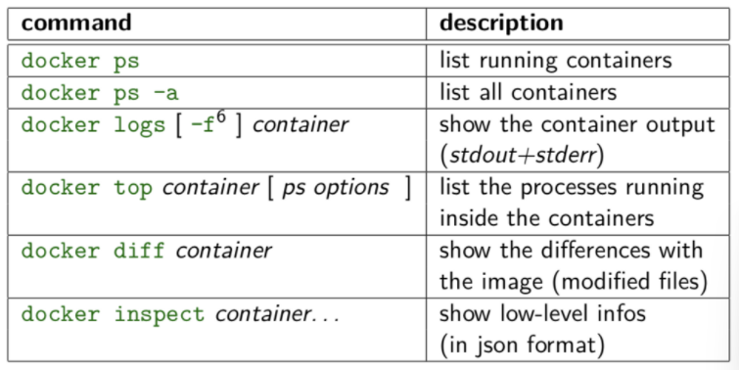

## Interacting with Container

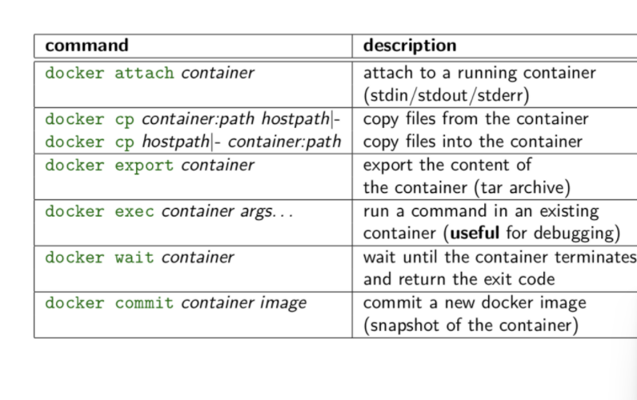

## Image Management Commands

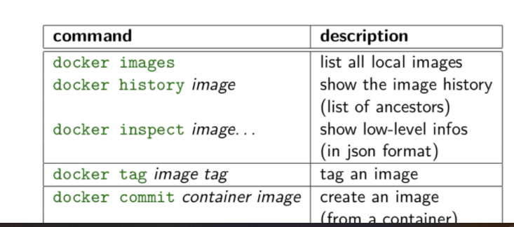

## Image Transfer Commands

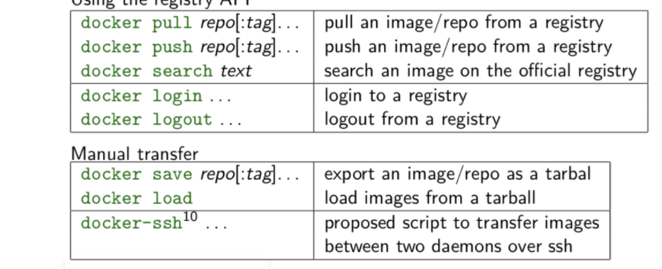

## Builder Main Commands

